+++++++++++++++++++

PowerBI Overview

About Powerbi security access and overview details.

Power BI is a Data Visualization and Business Intelligence tool that converts data from different data sources to interactive dashboards and BI reports. Power BI supports large range of data sources and provides a strong backend data manipulation feature with access to simple visualizations and It is closely integrated with Office 365, hence provides connectivity to SharePoint. And Power BI uses cloud storage and includes simple implementation process.

2018

PowerBI Team

IGI

3/6/2018

**PowerBI Security Access**

**Data Source Access Methods**

**Import:**

* Extracts the data from database and push it into the Power BI Desktop.
* Gives the full suite of transformation and data manipulation in the Desktop.
* Consumes and pushes the data into the Power BI Azure backend (Azure DB/Blob Storage) (In the Service)
* No need to republish the dashboard for updated data; it will get the latest data via schedule refresh option.
* The selected tables and columns are imported into **Power BI Desktop**. As you create or interact with visualization, **Power BI Desktop** uses the imported data.
* You must refresh the data, which imports the full data set again, to see any changes that occurred to the underlying data since the initial import or the most recent refresh.
* On the other hand, all data are stored on Power BI. So if you have requirement for Row Level Security (RLS), you need to implement it on Power BI side. If you need same logic applied for multiple reports, you have to duplicate it in all the reports. Same applies to calculations, if you need same measure in multiple reports you need to recreate it every time.

**Schedule refresh: (Import)**

* We need to set schedule refresh option, to pull/see latest data in the dashboard, if we create report using Import option.
* Dashboard->settings->dataset->select report->schedule refresh.

**Direct Query:**

* Directly access the data from Source (we won’t have copy of data in power BI deskktop).
* Limits the ability to manipulate data in the Desktop (removes the Data section)
* Since we are directly accessing data from the Source, no need to schedule a refresh Activity and 1 GB dataset limitation does not apply to Direct Query.
* Time intelligence capabilities are not available in Direct Query. For example, special treatment of date columns (year, quarter, month, and day, so on) is not supported in Direct Query mode.
* There is a 1 million row limit for returning data when using Direct Query
* If it returns more than 1 million rows from Direct Query, then Power BI returns an error.
* Since the data is directly pulls from source, in power BI Desktop visualization we will be able to see the Current data.
* In Direct Query Power BI doesn’t support changing from one data source to other data Source.

**Note**: For doing schedule refresh to a report both Import and Direct query requires a gateway to be installed, except for Azure SQL.

**Schedule refresh -cache: (direct Query)**

* If we create report using Direct Query option, before we publish the report in the cloud, **gateway should be installed and connection string should be configured.**
* Report created using direct query need to set the schedule refresh cache option.

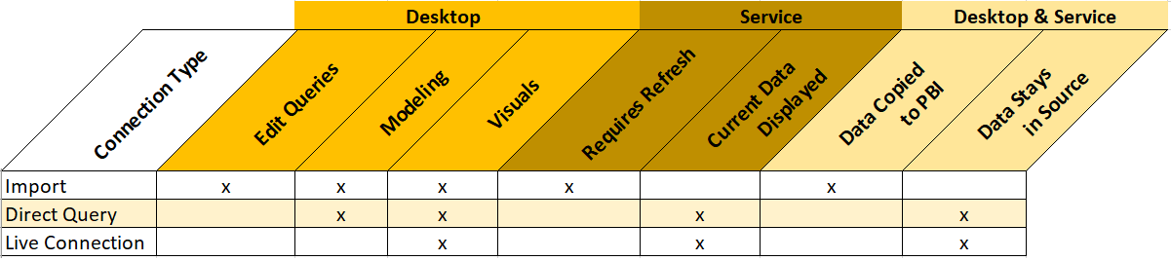

**Restrict Access to Dataset:**

* If we want to show only the set of details in the Report then Row Level Security can be used.
* RLS is the only secure way to manage what people see in a combined dataset.
* Restrict the data access by users.
* Filters data on row level.
* Define filters within roles and table rules.

**Premises Data Gateway**

**Personal data gateway:**

* Allows one user to connect to sources, and can’t be shared with others. Can only be used with Power BI.

**On-premises data gateway:**

* Allows multiple users to connect to multiple on-premises data sources, and can be used by Power BI, PowerApps, Flow, and Azure Logic apps, all with a single gateway installation.

**Access Permissions**

**Private access:**

To provide access to report, follow below settings:

Dashboard ->share->manage permissions-> (by default write, re-share, read will be enabled), but we can restrict using appropriate option as per business requirement.

**Note:** all reports need to share via report not via dashboards.

**Organizational access:**

This is similar to Private access, but all users belong/part of the domain will be able to access the report.

**Note:** all reports need to share via report not via dashboards.

For example:

If ([yyy@healthec.com](mailto:yyy@healthec.com) ) yyy user shared dashboard/report to xxx user ([xxx@healthec.com](mailto:xxx@healthec.com)), then xxx user able to see the report, according to access/permission provided (read, write and reshare option)

If ([yyy@healthec.com](mailto:yyy@healthec.com) ) yyy user shared dashboard/report to xxx user (xxx@gmail.com,) then xxx user can’t see the report ,once open a report it will ask the access permission request as shown in the below screenshot (Fig: 1).

Fig:1

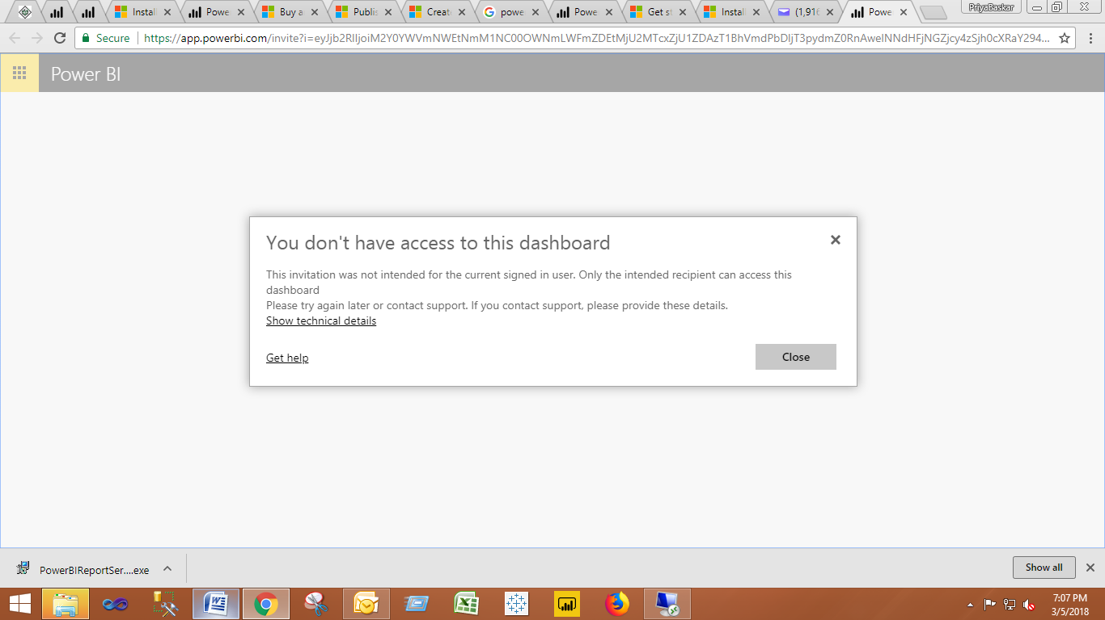

**Public access:**

If we share a report to another user in a same domain, that user can able to Edit/Re-share the report without asking the access permission request.

Dashboard ->related content->manages permissions->read-only/ Re-share.

**Microsoft Power BI Best Practices**

* Make datasets user friendly. Rename tables and columns to descriptive terms, remove unnecessary columns, hide columns not needed by users and make sure data types and formats are correctly assigned.
* Reduce data model sources and columns/rows to only what data is necessary (for performance and too simplify data selection for users).
* Data types should be specified in order to improve performance and usability. For example, names should be strings, revenue should be a decimal, headcount should be an integer and close date should be a date.

**Note that if Power BI detects a null value or error in a column record, it will not specify the correct data type for the entire column so you will need to manually make these corrections.**

* When merging tables and applying primary/foreign key relationships, if possible, use single column integer keys for maximum performance. Or you may use or create a surrogate key (for ex identity column which is Integer data type) for this purpose. This method will deliver a big performance improvement. If for some reason you don't want to use an integer key, date is the next best option.
* Data models should be filtered and normalized. This is particularly important if datasets are sourced from high data volume repositories.
* Normalize your data when building the dataset using the Designer Relationships view. Normalization separates unrelated table data and parses grouped data in a single column to multiple columns (date/time, names and addresses are prime examples) in order to optimize query performance.
* Use a star schema when designating table relationships. This consists of a central fact table (i.e. transactions) encircled by dimension (i.e. master) tables. Star schemas improve query and aggregation performance.

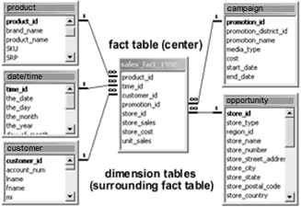

* And also we can use snowflake schemas. This topology has lookup tables which link to other lookup tables instead of linking back to the Fact table. This can limit scalability, but where data volumes are not large it also improves usability.

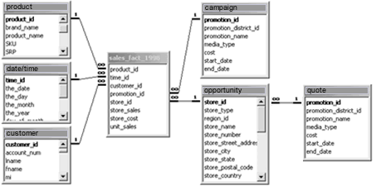

* Denormalizing the data may be helpful for reporting purposes. Denormalization can simplify report or dashboard creation and improve read performance by adding redundant data or grouping data. It's possible that to create a star schema you will need to do some data denormalization. The optimal method is to create a database View that pulls from multiple tables, however, you can also do this in Power BI by merging queries or creating a query that combines data into a single dimension table.
* The Query tool accesses tables and views (along with many other types of files). A view is a saved database query to simplify the dataset or hide the query complexity. Views can also be used to hide or remove columns for security purposes.
* Power BI Q&A performs a keyword search on dataset tables, columns and calculated field names. It reforms your question with auto-completion and restatement, and picks the best visualization to display your answer. The visualization changes dynamically as you modify the question. Here’s several tips to improve Q&A effectiveness.

## Power BI Advantages

* Power BI puts business intelligence creation into the hands of analysts who can extract source data, create a dataset, transform or manipulate the data, visualize the data and publish the resulting reports and dashboards. For progressive or iterative analysis, analysts can evolve the BI with new measures or dimensions.
* The Question and Answer (Q&A) function may be the top cited benefit and capability in achieving self-service BI.
* The dashboard visualizations are best in class and continually updated from the [community](https://app.powerbi.com/visuals/) (design visualizations). Interactive geo-map visualizations are empowered by Bing Maps.
* The underlying Power BI technology is an in-memory analytics engine and columnar database that supports tabular data store structures used by Power Pivot. This achieves a balance between performance and ease of use (as compared to three dimensional cubes which require more complex assembly and query languages, such as MDX (multidimensional expressions) for SSAS).
* The DAX (Data Analysis Expressions) scripting language is a relatively simple construct used to create calculated columns and measures. It's similar to Excel, although while Excel is cell based, DAX is column based.
* The pace of innovation is amazing. The product is updated about monthly.

**Power BI Disadvantages**

* Power BI reports and dashboards cannot accept or pass user, account or other entity parameters. This makes it impossible to create entity specific dashboards such as a dashboard for an account, opportunity, case, or campaign. Instead, dashboards are limited to aggregate views of entity data.
* There are only a few limited data sources that permit (near) real-time connections to your Power BI reports and dashboards. Also, using these real-time connections limits Power BI access to a single data source, voids the Edit View and eliminates key capabilities such as the Q&A and Quick Insights functions.
* Dashboards and reports can only be shared with users who have the same email domains or email domains listed with your Office 365 tenant.
* While a dataset can include multiple data types, Power BI reports and dashboards can only source data from a single dataset. Similarly, Power BI cannot mix imported data with data accessed from real-time connections. It's one or the other.
* Power BI will not accept files larger than 250 MB. Power BI files - .pbix – are actually a type of archived zip files so they do compress the data until it's needed by the xVelocity in-memory database engine, but the maximum accepted file size may still limit Power BI to subsets of enterprise data warehouses.
* There is a 1GB limit per dataset. As a workaround, you can create multiple datasets. There is also a maximum of 100,000 records in PowerBI.com.
* The solution can be deployed on-premise using the Power BI Report Server; however, the cost rises dramatically.
* This Microsoft solution is normally used to extend ― not replace ― other reporting tools. In most cases, it will not replace your enterprise data warehouse. For most companies, it is likely that their enterprise data warehouse tools will continue to be used for high volume data processing reports which do not change much, while Power BI may be used for one time, progressive or more frequently changing analysis on smaller data sets.
* Does not support other joins except inner join while connecting between the tables in Relationships Tab, However we can explicitly achieve through Merge Questies (Edit Queries)

**Power BI Desktop – Memory Usage**

Firstly, 250MB was a previous limit which is for the data model within a .pbix file. According to this blog,

the limit has been increased to 1 GB.

Secondly, there is no restriction on how large a pbix file can be locally. However, when you publish a pbix file which exceeds 1GB to Power BI Service, will get a file size limit message.

In the first stage when we import a pbix file which is less than 1GB to the power BI Service and later when the data model grows beyond 1 GB after a period of time, you will get a limitation message when refreshing the dataset.

# Change Published report dataset dynamically

# <https://community.powerbi.com/t5/Service/Change-Published-report-data-s-Dynamically/m-p/66509#M12869>

* Once the relation between report and dataset is established on the service, we are not able to replace dataset for the report currently, except republish reports from the Power BI Desktop, or design a new report from the other dataset on service.  Need to change connection string then republish report to service.

# Accessing multiple datasets in single report

# [https://ideas.powerbi.com/forums/265200-power-bi-ideas/suggestions/12456786-accessing-multiple-datasets-in-single-report`](https://ideas.powerbi.com/forums/265200-power-bi-ideas/suggestions/12456786-accessing-multiple-datasets-in-single-report%60)

* Currently Power BI doesn’t have this feature. Find the Above link for more information.

# Power BI Report Server Integration (Configuration Manager)

# <https://docs.microsoft.com/en-us/sql/reporting-services/install-windows/power-bi-report-server-integration-configuration-manager>

# Getting Latest Data in Published Report:

# <https://community.powerbi.com/t5/Desktop/Dynamically-change-data-source-of-published-report/td-p/130324>

# <https://docs.microsoft.com/en-us/power-bi/guided-learning/publishingandsharing>

* If we have on-premises gate way in our system, we can get the latest data from the source, by hitting “refresh” button.
* By giving the data source information in the Gateway, report will connect to data source.

Settings-> Manage gateway